

Activity 1: Job riddles: What’s my job? Match the pictures with the sentences.
- I have students. I work in a school. I give homework. ………………..


- I travel a lot. I wear a uniform. I fly planes. ………………..
- I wear a uniform. I make sick people feel better. I work in a hospital. …………..
- I work in a garage. I use different tools and keys. I fix cars. ………………
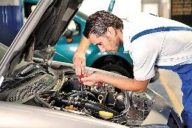
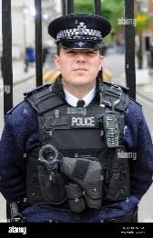
- I work in a hospital. I help doctors. I wear a uniform. …………….
- I work in a restaurant. I prepare food. I stay in the kitchen. …………
- I work in an office. I send emails. I make coffee. ………….

- I have a gun. I wear a uniform. I catch thieves. ……………..

- I perform on a stage. I have concerts. I make people feel relaxed. ……….


- I have a bus. I travel all day long. I carry people. ………

Activity 2. Find 10 words related to jobs. Words can be found vertically, horizontally and diagonally.

B | N | A | C | H | E | F | L | L | P
M | U | C | B | Y | R | N | D | T | O
E | R | S | U | P | I | L | O | T | L
C | S | I | D | A | W | U | C | E | I
H | E | M | S | R | R | I | T | A | C
A | N | C | R | E | I | H | O | S | E
N | V | O | G | E | B | V | R | Y | M
I | O | N | T | T | A | Y | E | W | A
C | I | T | E | A | C | H | E | R | N
S | E | C | R | E | T | A | R | Y | R
…………………………………
………………………………….
………………………………….
………………………………….
………………………………….
………………………………….
………………………………….
………………………………….
Solutions:

A. 1. teacher
2. pilot
3. doctor
4. mechanic
5. nurse
6. chef
7. secretary
8. policeman
9. singer
10. bus driver

B.
B | N | A | C | H | E | F | L | L | P
M | U | C | B | Y | R | N | D | T | O
E | R | S | U | P | I | L | O | T | L
C | S | I | D | A | W | U | C | E | I
H | E | M | S | R | R | I | T | A | C
A | N | C | R | E | I | H | O | S | E
N | V | O | G | E | B | V | R | Y | M
I | O | N | T | T | A | Y | E | W | A
C | I | T | E | A | C | H | E | R | N
S | E | C | R | E | T | A | R | Y | R

