Lesson Plan

Level, age of the students: |  | 8th grade, 14-15 years old
Subject: |  | Geography
Subjects involved: |  | IT
Aims: |  | Students will be able to identify the four sectors of activity and the jobs associated with each sector.  Students will be able to become more aware of their inclinations for different jobs.
Suggested # of students per group: |  | 20
Time of the main activity: |  | 15 min.
Material: |  | Video projector, mobile phones
Competences: |  | Digital competence  Social and civic skills
Preparatory actions if any: |  | Students need to know the capabilities and applicability of their mobile phones and computers. They must know the application used.
Expected results: |  | Students will be able to fit the jobs into the main fields of activity.  Students will become more aware of which jobs suit them.
Expected difficulties: |  | Students may have difficulty choosing a job that matches their abilities.
Follow up if any: |  | Students will also ask for the opinion of their peers about their inclinations.
Time | PROCEDURE (T: teacher; SS: students; O: other) |  | METHOD
2’ | - Preparatory action  Objective: To know the four fields of activity  T: Shows the chart with the occupational structure of the EU population in 2021.  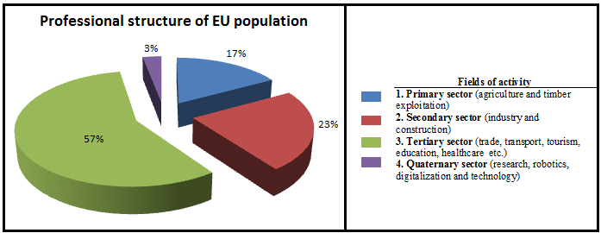  SS: Interpret the diagram and argue the different share of the four sectors of activity. |  | Presentation  Conversation
5’ | - The grouping of jobs by fields of activity  Objective: To know the most important jobs and the fields of activity they belong to.  T: Ask students to solve the exercise: Open the link and match the jobs shown to one of the four areas of activity.  SS: Associate (individually or in pairs) the trades presented to one of the four fields of activity.  T: Check that your solution is correct.  SS: Share their problems (if any). |  | https://learningapps.org/watch?v=p3qkme2sa23  Individual or pair work
5’ | - The evolution of jobs on the labor market  Objective: To understand the dynamics of jobs in the labor market.  T: Ask the students to solve the exercise: Open the link and associate the fields of activity with the development trends specific to each field.  SS: Associate (individually or in pairs) the fields of activity with the development trends specific to each field.  T: Starting from the material presented, the teacher asks the students to identify the jobs that will be most sought after in the future on the labor market.  SS: Give examples of such jobs. |  | https://learningapps.org/watch?v=p02xvpoon23  Frontal work
3’ | - Closing Activity  Objective: To compare their own options regarding the jobs they would like to have with the current trends in the labor market.  T: Asks students: Complete the form by accessing the link.  SS: Fill in the form.  T: Shows the grade level percentages for each of the four domains.  SS: Compare the obtained percentages with the current occupational structure of the EU population. |  | https://forms.gle/McKKBPc5TJtKo5Qq6  Comparison

