Annex 1

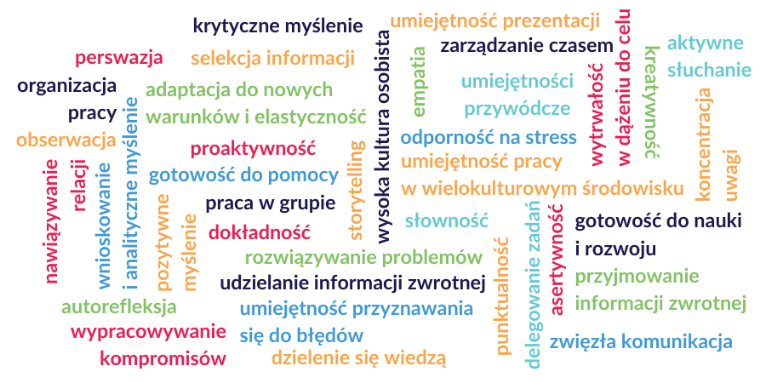

1. Communicability
2. Reliability
3. Entrepreneurship
4. Disciplining
5. Creativity
6. Openness
7. Ability to work in a team
8. Independence
9. Initiative
10. Accuracy
11. Conscientiousness
12. Driving licence
13. Market knowledge
14. Concentration
15. Knowledge of legal issues
16. Effective information management
17. Empathy
18. Fluent knowledge of a foreign language
19. Knowledge of specialized vocabulary
20. Assertiveness
21. Ability to manage the budget
22. Positive thinking
23. Interpersonal skills
24. Analytical skills
25. Ability to operate office equipment
26. Readiness for self-education
27. Self-discipline
28. Punctuality
29. Patience
30. Attention to detail
31. Stress resistance
32. Innovation
33. Concentration

