Appendix – Maths – Graph of the function
Task
The graph shows changes of shares of certain company in first two weeks of July.
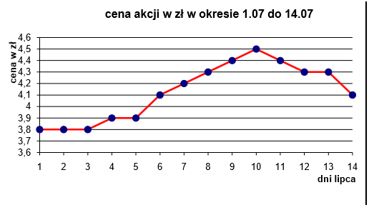
Price of shares in zlotys in period between 1.07 and 14.07
vertically: prize in zlotys horizontally: days in July

Questions to the task:
1. Which was the highest and which the lowest price of shares of the company in presented period?
2. In which day it was the most preferably to sell these shares?
3. Mr Kowalski bought 250 shares on 9 July and Ms Nowak also 250 shares on 6 July. How much less did Ms Nowak pay?
4. You have at your disposal 1000 zlotys. Count how much you could earn on buying and selling shares of this company, taking into consideration that we buy and sell shares in the most beneficial moment.

Fill in sentences answering questions from the task.
In the first two weeks of July price of shares fluctuated from …………. zlotys for 1 share to …………. zlotys for 1 share. The person who wanted to sell these shares most beneficially did it on ………….. July. On 9 July Mr Kowalski for 250 shares paid …………….. zlotys and Ms Nowak also for 250 shares on 6 July paid ……….. zlotys. Ms Nowak paid ……………. zlotys less. For 1000 zlotys on …………. July you can buy …….. shares. Selling them on …………. July you will get ……….. zlotys. The profit comes to ………… zlotys.

Comment of the teacher after doing the task and checking answers.
Graphs in many fields are carriers of important information: financial, stock exchange, statistical, medical. We can quote many examples of application of graphs in everyday life and in different fields of science. Reading and analysing data skill is useful in many occupations.
Allocation of a project task after doing an exercise.
- Division of students into groups of 3
- During a week every group searches for graphs showing information from different fields together with examples of occupations, in which ability to analyse the information is essential. The work must result in a 5-minute presentation, which will be shown by groups during a lesson.

